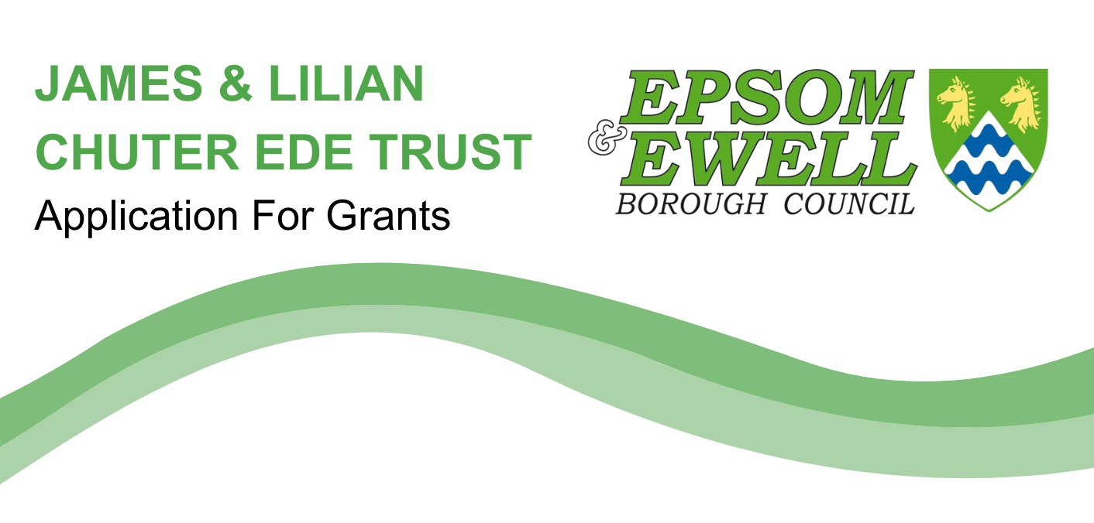
Name: .....................................................................................

Home address: .....................................................................................

Email address: .....................................................................................

Telephone number: .....................................................................................

Residential university: .....................................................................................

University address: .....................................................................................

Course: .....................................................................................

Is this your first degree course?: YES/NO

If the answer is “No”, please give details of degree(s) held:

.....................................................................................................................................

When did / will your present course commence?: ..............................................

How long have you lived in the Borough of Epsom & Ewell? ............. years

Have you previously received a grant from this Trust? YES/NO

I declare that the above information is true to the best of my knowledge.

Signed: ................................................ Date: ..................................

WHAT TO DO NEXT
- Send the completed application form to chuterede@epsom-ewell.gov.uk or Chuter Ede Application, The Old Town Hall, The Parade, Epsom, KT18 5BY.
- Enclose proof of attendance at university, such as a Tutor’s letter, confirmation of offer and acceptance into university, and/or offer of residential accommodation.

IMPORTANT INFORMATION
- The closing date for receipt of applications for 2023 is Sunday 1 October 2023
- The maximum award is £250 and may be less depending on the number of applications received
- The council reserves the right to not make any award of grant
- Successful applicants are expected to use the grant for purposes solely connected with their course, such as buying books or materials, while in attendance at University
- The objectives of the above Trust are to financially assist people ordinarily resident in the Borough of Epsom & Ewell who for the time being are resident students at a residential University in the UK (i.e., living away from home), in order that they may obtain a full benefit of residence at such Universities.

