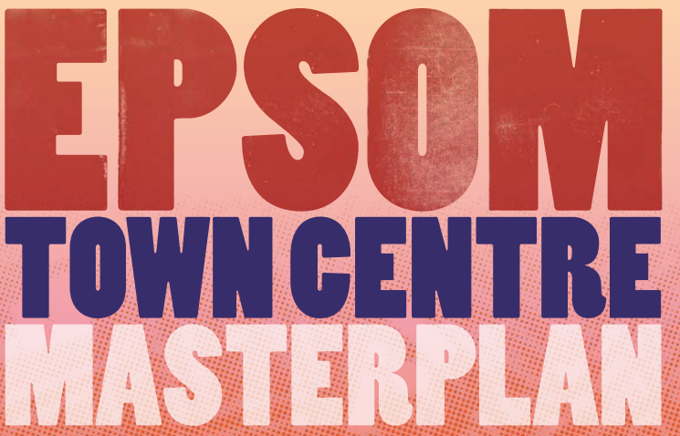

Name

Email Address

Address
Note: Details are needed to confirm legitimacy of response. Your response will be published on our consultation portal along with your name following the close of the consultation.

Please answer as many of the following 15 Questions as you would like. For ease of reference, we have provided the corresponding page numbers of the “Draft Epsom Town Centre Masterplan” document under each question.

Please return your completed response form by email (localplan@epsom-ewell.gov.uk) or by post to the following address by 23:59 on the 22 December 2023.

Town Centre Masterplan Consultation
Epsom and Ewell Borough Council
Town Hall,
The Parade
Epsom
Surrey
KT18 5BY

Question 1 To what extent do you agree with the masterplan principles?
Page reference 1 - 9
Select the most applicable option in each row.
 | Strongly Agree | Agree | Neutral | Disagree | Strongly Disagree
 | [ ] | [ ] | [ ] | [ ] | [ ]
Please enter any additional comments:

Question 2 To what extent do you agree with the baseline analysis?
Page reference 10 - 19
Select the most applicable option in each row.
 | Strongly Agree | Agree | Neutral | Disagree | Strongly Disagree
 | [ ] | [ ] | [ ] | [ ] | [ ]
Please enter any additional comments:

Question 3 To what extent do you agree with the design response?
Page reference 19-21
Select the most applicable option in each row.
Strongly Agree | Agree | Neutral | Disagree | Strongly Disagree
[ ] | [ ] | [ ] | [ ] | [ ]
Please enter any additional comments:

Question 4 Do you think the "Character Areas" are an accurate representation of different areas of the town centre?
Page reference 22:
Yes | [ ]
No | [ ]
Don’t Know | [ ]

Please enter any additional comments:

Question 5 Do you have any comments on our analysis of the character areas (please specify which ones)?
Page reference 22 – 35:

Question 6 Do you have any comments on the public realm strategy?
Page reference 36 – 42:

Question 7 Do you have any comments on the draft transport strategy?
Page reference 43 – 45:

Question 8 Do you have any comments on the targeted interventions on the A24 (Please specify, e.g. Ashley Avenue, Ashley Road, High Street, Church Street or East Street).
Page reference 46 - 50:

Question 9 Do you have any comments on proposals for either Upper High Street and/or Waterloo Road / Station Approach? (please specify).
Page reference 51 - 52:

Question 10 Do you have any comments on Public Car Parking?
Page reference 53:

Question 11 Which is your preferred option for the following sites?
Page reference 54 - 72
Select the most applicable option in each row.

 | Option 1 | Option 2 | Option 3
Ashley Centre and Global House | [ ] | [ ] | [ ]
Hook Road and Southern Gas Network | [ ] | [ ] | [ ]
Town Hall, Hope Lodge and Epsom Clinic | [ ] | [ ] | [ ]

Please enter any additional comments, including alterative suggestions (please be specific).

Question 12 Please indicate which your preferred options would be for the following site.
Page reference 73 - 76:
Select the most applicable option in each row.
 | Option 1 | Option 2
Depot Road and Upper High Street | [ ] | [ ]

Please enter any additional comments including for suggested alternatives.

Question 13 Do you have any comments to make on Appendix A: Townscape and Heritage Views?

Question 14 Do you have any comments on Appendix B: Stage 1 baseline report?

Question 15 Are there any general comments you'd like make about the Draft Masterplan?

