

Keep your home free from damp and mould

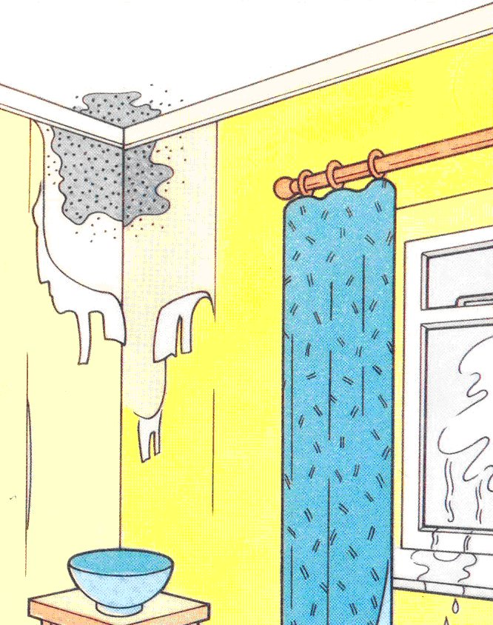
Is your home damp? Damp can cause mould on walls and furniture and make window frames rot. Damp housing encourages the growth of mould and mites, and can increase the risk of respiratory illness.

Some damp is caused by condensation. This leaflet explains how condensation forms and how you can get rid of it.

First steps against condensation

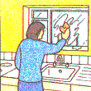
You will need to take steps to deal with the condensation, but meanwhile there are some simple measures you can take right away.

Wipe down the windows and sills every morning. Wring out the cloth rather than drying it on a radiator.

Condensation channels and sponge strips can be bought at DIY shops. They are fitted to windows to collect the condensation and thus help prevent window frames from rotting and avoid damp forming under sills.

First steps against mould

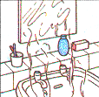
First treat the mould already in your home. If you deal with the basic problem of condensation and damp, mould should not then reappear.

To kill and remove mould, wipe down walls and window frames with diluted bleach or fungicidal wash. Dry-clean mildewed clothes, and shampoo carpets. Do not try to brush mould away - use a vacuum cleaner.

After treatment, redecorate using a good quality fungicidal paint to help prevent mould. Note that this paint is not effective if overlaid with ordinary paints or wallpaper.

The only lasting way of avoiding severe mould is to eliminate dampness.

Is it condensation / dampness?

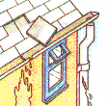
Condensation is not the only cause of damp. It can also come from:

- leaking pipes, wastes or overflows
- rain seeping through the roof where a tile or slate is missing, spilling from a blocked gutter, penetrating around window frames, or leaking through a cracked pipe
- rising damp due to a defective damp course or because there is no damp course

These causes of damp often leave a ‘tidemark’.

If your home is newly built it may be damp because the water used during its construction (e.g. in plaster) is still drying out.

If your home is damp for any of these reasons it may take weeks of heating and ventilating to dry out. Hiring a dehumidifier will help.

If you do not think the damp comes from any of these causes, it is probably condensation.

What is condensation?

There is always some moisture in the air, even if you cannot see it. If the air gets cold it cannot hold all the moisture and tiny drops of water appear. This is condensation. You notice it when you see your breath on a cold day, or when the mirror mists over when you have a bath.

Condensation occurs during cold weather, whether it is raining or dry. It does not leave a ‘tidemark’. It appears on cold surfaces and in places where there is little movement of air. Look for it in corners, on or near windows, in or behind wardrobes and cupboards. It often forms on north facing walls.

How to avoid condensation

These four steps will help you reduce condensation in your home.

Produce less moisture
Some ordinary daily activities reduce a lot of moisture very quickly:

- Cooking: To reduce the amount of moisture in the kitchen, cover pans and do not leave kettles boiling
- Paraffin and portable flue less bottled gas heaters: These heaters put a lot of moisture into the air – one gallon of gas or paraffin produces about a gallon of water. If you do have a problem with condensation, try to find alternative means of heating
- Washing clothes: Put washing outdoors to dry if you can. Or put it in the bathroom with the door closed and the window open or fan on. If you have a tumble dryer make sure you vent it to the outside (unless it is the self-condensing type). DIY kits are available for this.

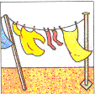
Ventilate to remove moisture
You can ventilate your home without making draughts. Some ventilation is needed to get rid of moisture being produced all the time, including that from people’s breath. Keep a small window ajar or a trickle ventilator open when someone is in the room.

You need much more ventilation in the kitchen and bathroom when cooking, washing up, bathing and drying clothes. This means opening the windows wider. Better still, use a humidistat-controlled electric fan.

Close the kitchen and bathroom doors when these rooms are in use even if your kitchen or bathroom has an extract fan. A door closer is advisable. Doing this will help stop the moisture reaching other rooms, especially bedrooms, which are often colder and more likely to get condensation.

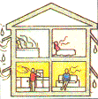
Ventilate cupboards and wardrobes. Avoid putting too many things in them, as this stops the air circulating. Cut a ventilation slot in the back of each shelf or use slatted shelves. Cut 'breather' holes in doors and in the back of wardrobes. Leave space between the back of the wardrobe and the wall. Put floor-mounted furniture on blocks to allow air underneath. Where possible, position wardrobes and furniture against internal walls, i.e. walls which have a room on both sides, rather than against outside walls.

If you replace your window units at any time, you should incorporate trickle ventilators.

Insulate and draught proof
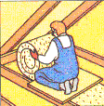
Insulation in the loft, cavity wall insulation and draught proofing of windows and outside doors will help keep your home warm and you will have lower fuel bills as well. When the whole home is warmer, condensation is less likely.

When draught proofing:

- do not block permanent ventilators
- do not completely block chimneys (leave a hole about two bricks in size and fit a louvre grille over it)
- do not draught proof rooms where there is condensation or mould
- do not draught proof a room where there is a fuel-burning heater (e.g. gas fire) or cooker.
- do not draught proof windows in the bathroom and kitchen.

If you live in a house, insulating your loft is a cost effective way of cutting heating costs. Remember to draught proof the loft hatch as well. Cavity wall insulation is also an effective way of cutting heating costs. Before you decided on this method of insulating, however, you should talk to your local building inspector. If you then go ahead with the work it should be carried out only by an approved contractor.

Secondary glazing of windows reduces heat loss and draughts but you must ensure that there is some ventilation.

Heat your home a little more
In cold weather, the best way to keep rooms warm enough to avoid condensation is to keep low background heating on all day, even when there is no one at home. This is very important in flats and bungalows and other dwellings where the bedrooms are not above a warm living room. So, if possible, install a very small heater with a thermostat in each bedroom (but do not use a paraffin or flue less bottled gas heater for this purpose). The thermostat will help control heating and costs.
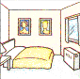
Dehumidifiers will help dry out damp in newly built houses. They can also help reduce condensation in warm rooms with a lot of moisture but they are of limited use in cold damp rooms.

Points to remember

Produce less moisture:
- cover pans
- dry clothes outdoors
- vent your tumble dryer to the outside
- avoid using paraffin or flue less bottled gas heaters

Ventilate to remove moisture:
- ventilate when someone is in
- increase ventilation of the kitchen and bathroom when in use and shut the door
- ventilate cupboards, wardrobes and blocked chimneys

Insulate and draught proof:
- insulate the loft
- draught proof windows and external doors
- consider cavity insulation
- consider secondary glazing
- find out if you are eligible for a grant

Heat your home a little more:
- if possible, keep low background heat on all day
- find out about benefits, rebates and help with fuel bills.

Advice and other information

If window frames etc in your home are affected by rot, you may decide to treat the wood with preservatives. A leaflet called Wood Preservatives in your Home gives valuable advice on the use of these chemicals. The leaflet is available from:

Department for the Environment, Food & Rural Affairs (DEFRA)
Tel: 020 8957 5242 or 08459 556000
website: www.defra.gov.uk

Surrey & East Sussex Energy Efficiency Service Centre is a ‘one-stop’ advice and referral shop for all your energy needs. It aims to raise awareness of energy efficiency and provides a simple route to grant schemes to make your home warmer, healthier and more energy efficient. Help could include:

- Grants (for measures such as loft and cavity wall insulation)
- Low cost and no cost tips to save you money

Actio₂n Surrey
Actio₂n Surrey is a partnership project that offers homeowners impartial advice on how to reduce energy in the home or install a renewable technology, like solar panels. It’s supported by several councils across Surrey, including Epsom & Ewell. Just some of the things available through Action Surrey are; impartial and practical energy advice, discounted insulation, a trusted installer network for renewable technology and case studies of residents who have been there and done it.
For more information please call 0800 783 2503 or visit the Action Surrey website.

BRE Scotland
Kelvin Road, East Kilbride, Glasgow, Scotland G75 ORZ
Tel: 01355 576200
website: www.bre.co.uk/services/Moisture.html

